**WEEK 6**

**241001218-SAMYUKTHA SOWMYANARAYANAN**

Q1.

Q1.II)

Q1.III)

Q2.

Sample Input 1:

5

30 40 50 20 10

20

Sample Output 1:

Element found at location : 3

Sample Input 2:

5

30 40 50 20 10

55

Sample Output 2:

Element not found.

**For example:**

| **Input** | **Result** |
| --- | --- |
| 5  30 40 50 20 10  20 | Element found at location : 3 |
| 5  30 40 50 20 10  55 | Element not found. |

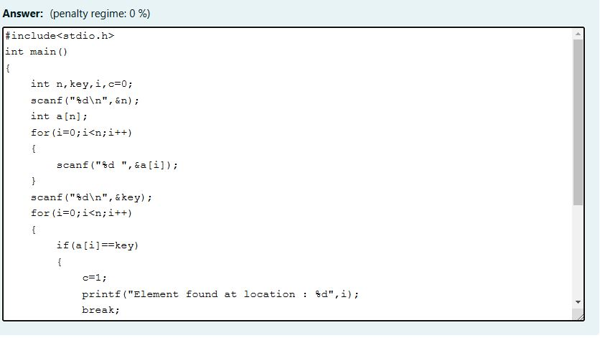

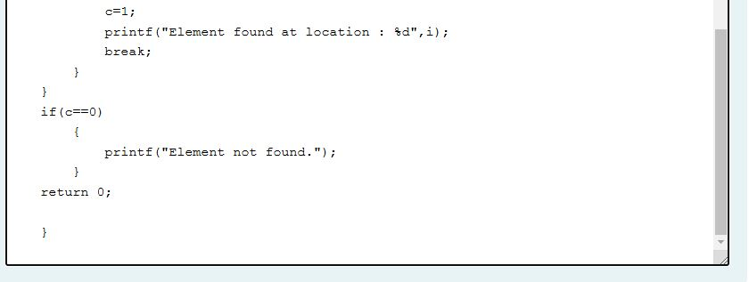

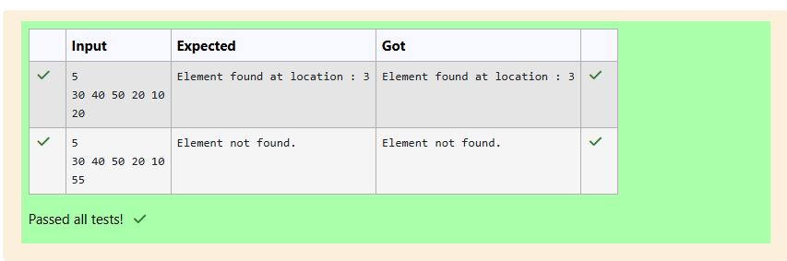

Q3.

Sample Input 1:

5

10 20 30 40 50

30

Sample Output 1:

Element found at location : 2

Sample Input 2:

5

10 20 30 40 50

55

Sample Output 2:

Element not found.

**For example:**

| **Input** | **Result** |
| --- | --- |
| 5  10 20 30 40 50  30 | Element found at location : 2 |
| 5  10 20 30 40 50  55 | Element not found. |

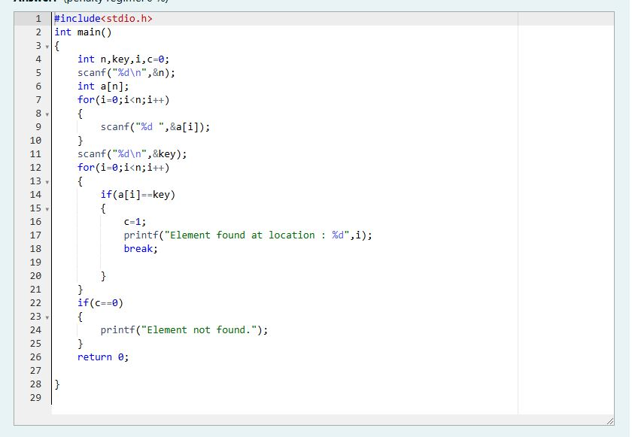

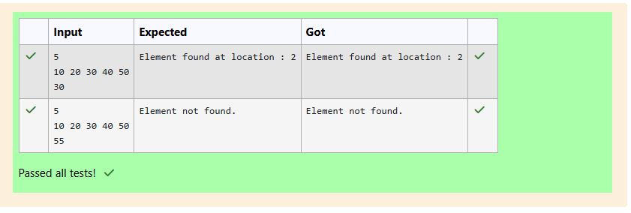

Q4.

Sample Input:

5  
30 40 50 20 10

Sample Output:

10 20 30 40 50

**For example:**

| **Input** | **Result** |
| --- | --- |
| 5  30 40 50 20 10 | 10 20 30 40 50 |

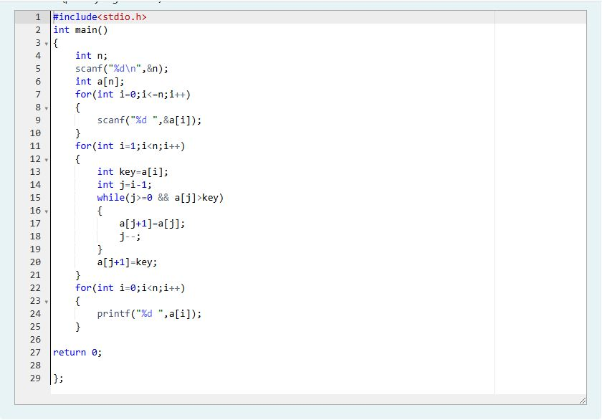

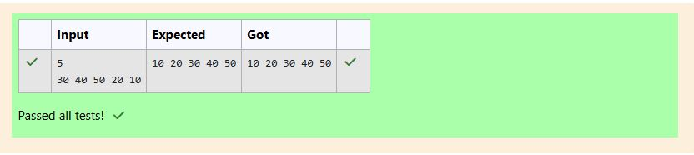

Q5.

Sample Input:

5  
30 40 50 20 10

Sample Output:

10 20 30 40 50

**For example:**

| **Input** | **Result** |
| --- | --- |
| 5  30 40 50 20 10 | 10 20 30 40 50 |

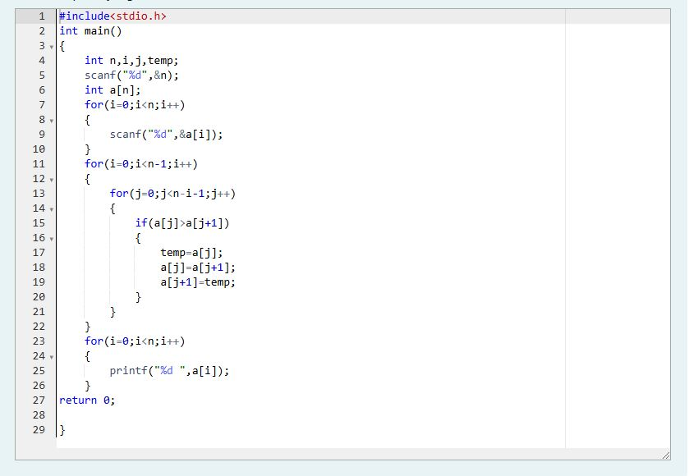

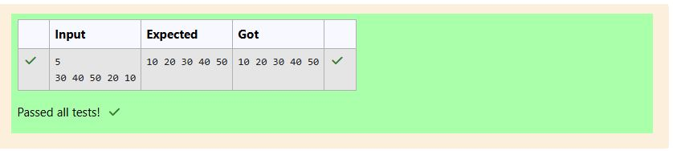

Q6.

Sample Input:

5  
30 40 50 20 10

Sample Output:

10 20 30 40 50

**For example:**

| **Input** | **Result** |
| --- | --- |
| 5  30 40 50 20 10 | 10 20 30 40 50 |

Answer:(penalty regime: 0 %)

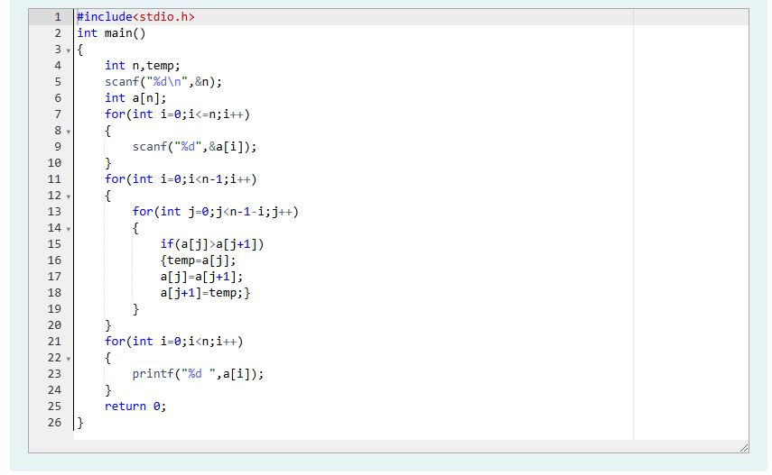

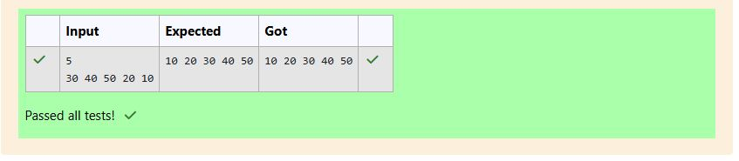

Q7.

Sample Input:

5  
30 40 50 20 10

Sample Output:

10 20 30 40 50

**For example:**

| **Input** | **Result** |
| --- | --- |
| 5  30 40 50 20 10 | 10 20 30 40 50 |

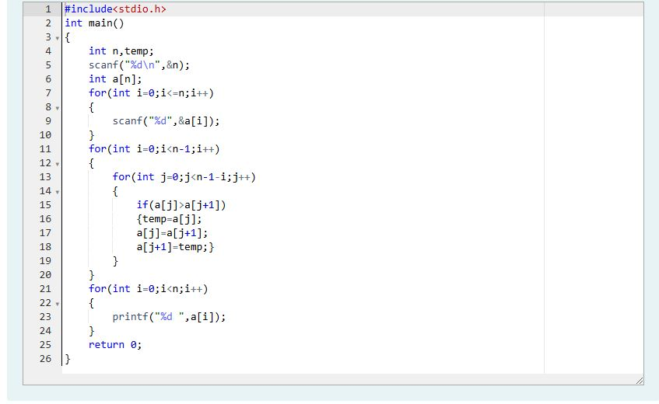



Q8.

Sample Input:

5  
30 40 50 20 10

Sample Output:

10 20 30 40 50

**For example:**

| **Input** | **Result** |
| --- | --- |
| 5  30 40 50 20 10 | 10 20 30 40 50 |



